Afiq Abdul Hamid  
18015518  
ASTR 800 Advanced Topics in Astrophysics Report

Table of Contents

1. Introduction
2. Gravitational wave astronomy
3. Gravitational waves
4. The search for gravitational waves
5. Gravitational waves sources
   1. Comparison with electromagnetic waves
6. The final parsec problem
7. Observatories around the world
8. Gravitational wave background
9. Gravitational wave astrophysical significance: multi messenger astronomy
   1. Tracing the kilonova, follow up observation
   2. Multi messenger astronomy
   3. Future implications of multi-messenger astronomy
10. Pulsar Astronomy
    1. A Brief History of Pulsars
    2. The Uses of pulsars
       1. Hulse Taylor Binary
       2. Millisecond Pulsar
    3. Pulsar Timing Array
       1. Hellings and Downs curve
    4. Pulsar spectroscopy
       1. Multipath scattering delay
       2. Time/ frequency domain resolution
    5. Cyclic Spectroscopy
       1. Advantages of cyclic spectroscopy
11. Conclusion and Future Works
    1. Birefringent Scintillation
    2. Final Remarks

# 1. Introduction

Millions of years ago; two stellar mass black holes began to orbit into each other emitting travelling distortions in the fabric of space and time called gravitational waves. After having rippled through the universe at the speed of light for over billions of years the travelling distortions encountered the 3rd planet orbiting a humdrum star tucked nondescriptly between the Sagittarius and Perseus Arms of the Milky Way Galaxy. On the planet, two light beams that had been positioned by its ape risen inhabitants to cancel each other out became a little out of step because of the travelling distortions producing a bright interference pattern. It was with that glint of optical light on the photodetector that the inhabitants of that planet confirmed the existence of gravitational waves ushering in a new era for astronomy and astrophysics. Although to most of the conscious apes that had organized the experiment the whole thing really seemed like quite the “stretch” of the imagination.

This paper seeks to explore the subject of advanced topics in astrophysics in 2 parts. The first part explores the search for gravitational waves which is mainly related to the study of big picture physics. The second part explores the subject of pulsars and their application that may help towards uncovering more of that that big picture. This part is more to related to the study of astronomy and astrophysics.

# 2. Gravitational wave astronomy

We live in very interesting times at the early 21st century. A time-period that comes with its own set of astrophysical mysteries. One such mystery is the nature of gravity which is one of the 4 fundamental forces of nature alongside the strong/ weak nuclear forces and electromagnetism. Gravity is the force that applies to very massive objects in the universe and it is the reason that galaxies are shaped the way they are, the reason that planets go around stars and not the other way around, and why apples fall onto the heads of English mathematicians trying to figure the whole thing out.

In 1687 one English mathematician named Isaac Newton had figured out a piece of that mystery and called it the law of universal gravitation that connects every particle in the universe with every other particle with a force that is directly proportional to the product their masses and inversely proportional to the square of the distance between their centres of mass. Newton was able to find out the ‘what’ of gravity but was unable to solve the ‘why’ and ‘how’ of gravity.

More than 200 years later in 1915, a German physicist/mathematician named Albert Einstein decided to pick up where Newton left off by introducing geometry into the picture in his General Theory of Relativity (GR). According to GR objects with mass create curvature in space time and move along geodesics of straight lines created by curvatures of even larger objects. The more massive the object the more curvature it creates, the more curvature created the stronger the effect of gravity.

In a nutshell (a very symmetric nutshell): mass tells space time how to curve while space time tells mass how to move.

## 2.1 Gravitational waves

A part of GR predicted of a phenomena called gravitational waves, which are described as travelling distortions in the fabric of otherwise flat Minkowsikan space time (Tiburzi, 2018) produced by accelerated mass distributions.

Any passing gravitational would have the effect of stretching and squeezing the geometry of space time almost like a rubber band. This stretching and squeezing effect manifests itself as a measurable geometric strain expressed as the rate of change of a length per unit length (𝛿L/L).

However, Einstein thought nothing much of this stretching and squeezing effect. He thought it was of little physical significance because they would be too faint to measure. In his 1916 GR paper stated that they would have “diminishing values in all cases”.

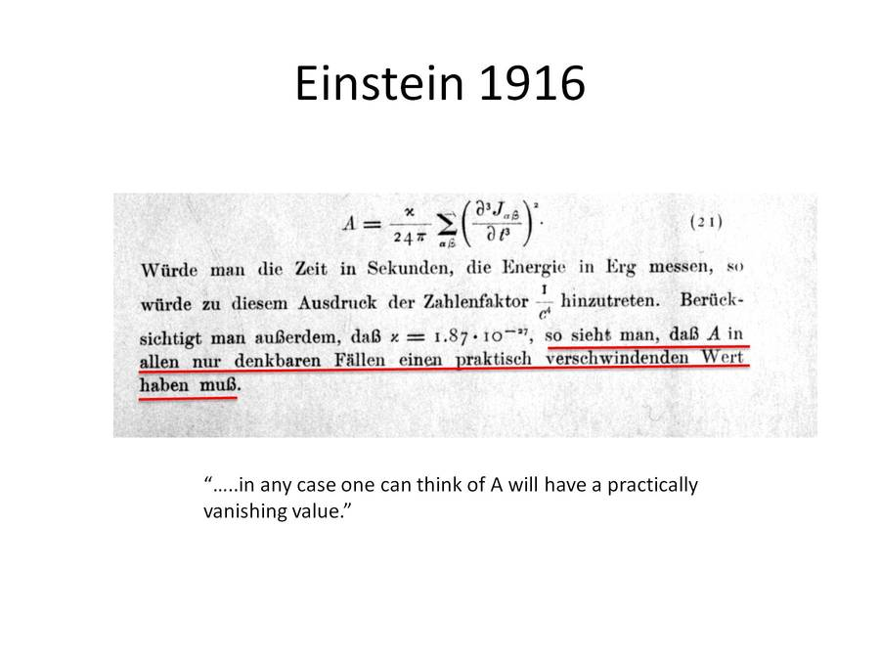

Figure 1: Einstein's original prediction of gravity waves and thinking that their values would be “disappearing in all cases” (Einstein, 1916)

Figure 1 shows Einstein’s original thoughts on the existence of gravitational waves where the value A is the rate change of length per unit length. The German word “verschwindenden” describes how the waves would “disappear” across all values. He was right in 1916. But now 100 years later standing on his shoulders, physicists, mathematicians, and astronomers get a chance to perhaps do to Einstein, what Einstein did to Newton and to take things one step further.

## 2.2 The Search for gravitational waves

To measure the faint distortions of space time that Einstein had disregarded, two types of conditions usually occur;

* Sufficiently long baseline measurement distances (L)
* Very small displacements measures. (dL)

For A to manifest itself as a very small value either the distance that we measure it over must be very large or the change of proper distance displacement measured must be very small. Gravitational wave observatories can be built to detect A, many have been proposed throughout the years such as the resonant mass antennas and laser interferometers, but only two are seriously considered in this paper: laser interferometers and pulsar timing arrays.

### 2.3 Gravitational waves sources

As mentioned gravitational waves are produced by accelerating masses. By waving one’s arms in the air one can produce gravitational waves however the effect is truly is too faint to be of consequence.

To produce gravitational waves that are detectable an extraordinary amount of mass in one location is needed. Their motion i.e. their orbits must cannot be spherically or rotationally symmetric.

Astrophysical phenomena that theoretically have enough mass to produce detectable gravitational waves include:

* Supermassive black holes: ≈ 108 - 109 M ☉
* Stellar mass black holes: 10 – 50 M ☉
* Neutron stars: 2 – 3 M ☉
* Core collapse supernovas

Gravitational waves are given off by these objects when they are in the configuration of an in-spiralling binary pair with each other or in the case of the supernova happen in a non-perfectly spherical manner. The binary pairs represent a type of changing quadrupole moment that gives off gravitational waves as they undergo orbital decay and eventually merge on very long-time scales. These merger events are some of the most energetic and violent collisions in the universe producing (several solar masses) × c2 joules of energy at their peak thus manifesting E = mc2 in the purest sense.

These merger events are a point of interest of study and research by astrophysicists because they present many unsolved mysteries in physics. One such mystery is the final parsec problem (Milosavljevi´ & Merritt, 2002) further explored in 2.4.

#### 2.3.1 Comparisons with electromagnetic waves

A comparison of gravitational waves and electromagnetic waves is presented in table 1 to get a better understanding of the two.

|  |  |  |
| --- | --- | --- |
| Characteristic | Gravitational Waves | Electromagnetic Waves |
| Source | Bulk acceleration of non symmetrical compact masses | Acceleration of charges. |
| Sign of charge | 1 single | 2 opposing |
| Speed | c (speed of light) | c (speed of light) |
| Propagation | Quadropole transverse | Dipole transverse |
| Matter Interaction | Weak: and goes through matter | Strong and is easily absorbed by matter |
| Polarization | 2 types:   * h+ * hx * Depending on orbit: * Elliptical * Circular | 3 types:   * Linear * Circular * Elliptical |

Table 1: Comparison of gravitational and electromagnetic waves.

The type of orbit of two compact masses whether elliptical or circular also influences the ‘sound’ frequencies produced by the radiating gravitational waves. This is likened to a form of polarization. Circular orbits produce a pure tone while elliptical orbits produce a ‘spikier’ frequency.

### 2.4 The final parsec problem

Based on theoretical models, the collision of SMBH during galaxy merger events contribute to the formation of structure in the universe usually follow this process:

* In-spiral: The SMBHB orbit each other giving off GW. The progenitor masses usually orbit each other very quickly at a fraction of the speed of light.
* Merger: The SMBHB coalesce producing a GW burst that permanently alters space time. This final GW burst is what observatories like LIGO aim to detect.
* Ringdown: Relaxation of local space time revealing the remains left in a spherical configuration.

When the orbiting masses are far apart from each other they conserve momentum by means of dynamical gas friction and interaction with the stellar masses around them. As the distance closes momentum is carried out of the system by stellar mass hardening with stars being ejected from it at a high velocity that is equivalent to the binary’s orbital velocity (Milosavljevi´ & Merritt, 2002) and finally via low frequency gravitational waves. Throughout out this process the binary’s binding energy increases as its semi major axis decreases until eventually the SMBH are within the last parsec of each other. Since most of the stellar mass around it is gone there is a difficulty of further shrinking the binary orbit to distances smaller than 1 parsec and the SMBHs end up stuck in place, never actually merging. This is the final parsec problem.

There is currently little observational evidence for SMBHB within less than a parsec of each other. Such a final merger is thought to be impossible in a spherical galaxy model, unlike with the assumption of a triaxial model that would allow such a final merger to occur (Mingarelli, 2019). This is one important conclusion on the subject matter of the way the structure of the universe is organised in terms of the distributions of galaxies that can be made by studying SMBH mergers when they happen, and it is a motivational highlight of the search for low frequency gravitational waves.

### 2.5. Observatories around the world

The effort to detect gravitational waves is a global scientific endeavour involving observatories and research institutions from many nations around the world. Several different methods and instrumentation devices have been applied to the challenge. The following section investigates the different types of observatories and the gravitational wave frequency range they seek to detect.

#### Ground based laser interferometers

Observatories: LIGO/ Advance LIGO United States, VIRGO Italy

GW Frequency Range: 10 Hz – 1 kHz

GW Strain Factor: 10-21 - 10-22

Interferometers are a very versatile and commonly used scientific tool that can be used to measure a diverse set of physical phenomena. They exist in many shapes, sizes and configurations but have the similarity that they work by superimposing signals to produce an *interference pattern* that when studied can shine a light on the nature of the objects that created them. The most common type of interferometer used is a Michelson interferometer.

Using very sensitive lasers in a Michelson interferometer configuration the LIGO Interferometers in the United States began construction in the early 1990’s and underwent its first light in 2002. After several initial observation runs with no apparent detections LIGO was upgraded to Advanced LIGO in 2015 operating at 3 times more sensitivity than the original design. Advanced LIGO was successful at detecting the first gravitational wave on the 14th of September 2015. It was a very historic day in science.

More gravitational wave events have been detected since and there have been 11 confirmed detections in total so far. Table 2 is a timeline of the detection of gravitational waves matched with their merger event sources. The results reveal that the remnant from the merger is several solar masses is less than the sum of the progenitor masses because some of the mass is loss after being away as gravitational wave energy.

One entry of note is GW170817 that represents the merger of 2 neutron stars in an event labelled as GW170817. In this event the progenitor masses were much of less mass than stellar mass black holes, but the result of the collision could either be a neutron star or a stellar mass black hole depending on the whether the resulting mass surpasses the Tolman-Oppenheimer-Volkoff limit which sets mass boundary between neutron star and black hole at 2.2 M ☉ (Margalit & Metzger, 2017)

|  |  |  |  |  |  |  |  |  |  |
| --- | --- | --- | --- | --- | --- | --- | --- | --- | --- |
| GW Event | Date Time Event | Object A | | Object B | | Remnant | | Mass Loss M ☉ | Comments |
| Type | Mass M ☉ | Type | Mass M ☉ | Type | Mass M ☉ |
| GW150914 | 14-09-2015 | BH | 35.6 | BH | 30.6 | BH | 63.1 | 3.1 | First Detection of BH Merger |
| GW151012 | 12-10-2015 | BH | 23.3 | BH | 13.6 | BH | 35.7 | 1.2 |  |
| GW151226 | 26-12-2015 | BH | 13.7 | BH | 7.7 | BH | 20.5 | 0.9 |  |
| GW170104 | 04-01-2017 | BH | 31.0 | BH | 20.1 | BH | 49.1 | 2.0 |  |
| GW170608 | 08-07-2017 | BH | 10.9 | BH | 7.6 | BH | 17.8 | 0.7 | Smallest BH merger mass |
| GW170729 | 29-07-2017 | BH | 50.6 | BH | 34.3 | BH | 80.3 | 4.6 | Largest BH mass merger |
| GW170809 | 09-08-2017 | BH | 35.2 | BH | 23.8 | BH | 56.4 | 2.6 |  |
| GW170814 | 14-08-2017 | BH | 30.7 | BH | 25.3 | BH | 53.4 | 2.6 | First Triple Detection/ VIRGO  First Polarization measure |
| GW170817 | 17-08-2017 | NS | 1.46 | NS | 1.27 | NS | 2.8 | 0.03 | First Neutron Star Merger |
| GW170818 | 18-08-2017 | BH | 35.5 | BH | 26.8 | BH | 59.8 | 2.5 |  |
| GW170823 | 23-08-2017 | BH | 39.6 | BH | 29.4 | BH | 65.6 | 3.4 |  |

Table 2: LIGO Detections and Progenitor/Remnant Mass Analysis. The mass of the remnant is slightly less than the sum of the progenitor masses because a few solar masses worth of it is converted into gravitational wave energy.

As of yet there have been no confirmed detections of BH and NS mergers (BHNS). Such a binary configuration of compact masses may be exceedingly rare because of the way in which binary systems of massive stars evolve. However, there is a possibility that they may be detected via gravitational wave observatories in the decades to come. Discovery of a BHNS binary would open the door for further multi messenger follow up studies (section 2.7) of joint gravitational wave and electromagnetic wave observations. BHNS binaries are a popular candidate for sources of short gamma ray bursts and other accelerated mass ejecta aka cosmic rays (M. Bhattacharya, P. Kumar, & G. Smoot 2019).

More detectors are soon to be built such as KAGRA (The Kamioka Gravitational Wave Detector) in Japan and INDIGO (Indian Initiative in Gravitational-wave Observations) in India which when added to the collection of pre-existing observatories will further help with gravitational wave polarization measurement and improving the localization accuracy to the GW source.

The creation of these observatories further highlights the nature of science as being a cross border, cross national effort that will foster ties of cooperation and peace between different peoples as well as to assist in technology transfer between societies that will no doubt contribute to economy of the nations involved. Just like withe the SKA being constructed in South Africa, future gravitational wave collaborations represent the democratization of science towards the common good of humanity. It would be wise for the long-term development of any nation be it New Zealand or Malaysia to have some participation in these kinds of major science projects.

#### Space based interferometers

Observatories: LISA

GW Frequency Range: 1mHz - 0.1 Hz

GW Strain Factor: 10-15 – 10-16

The Laser Interferometer Space Antenna (LISA) is a project under the European Space Agency (ESA) that will take the LIGO concept to space to detect gravitational waves with frequencies between pulsar timing arrays and laser interferometers. LISA comprises of a constellation of 3 Satellites arranged in an equilateral triangle with sides 2.5 million km long, placed in a heliocentric orbit. The proper distance between the satellites is precisely monitored to detect a passing gravitational wave.

The project is due to launch in 2034.

#### Radio telescope and radio interferometers

Observatories: Arecibo, Greenbank, Parkes, SKA

GW Frequency Range: 10-8 – 10-9 Hz

GW Strain Factor: 10-15

Using the nature of pulsars as very accurate ‘cosmic clocks’ and the most powerful radio telescopes to measure the arrival times of the pulses on Earth, PTA’s are a promising detection method for gravitational waves emitted from SMBHB collisions during galaxy merger events. These black holes take millions of years to merge and take decades to complete a single orbit. However, as they merge they produce a stochastic GWB signature that should be detectable with PTA experiments in the decades to come.

The latter half of this paper talks about pulsar timing and pulsar spectroscopy techniques that can be applied to meet this overarching objective.

#### Cosmic microwave background radio telescope

Observatories: POLARBEAR, SPT, BICEP2

According to Inflation theory, the rapid inflationary expansion of the universe following the big bang produced primordial gravitational waves that manifests in the B-mode polarization of the (CMB).

These experiments use bolometers and gravitational lensing techniques to measure for the curl component of the CMB. Some detections within the last decades looked promising however upon further investigation by the Plack satellite were attributed to cosmic dust. The lesson from the story is to quote AUT professor Robin Hankin is; “verify”

#### Summary

In summary, the search for gravitational waves encompasses different frequency bands that are detected using different instruments and methods and is summarised in figure 2.

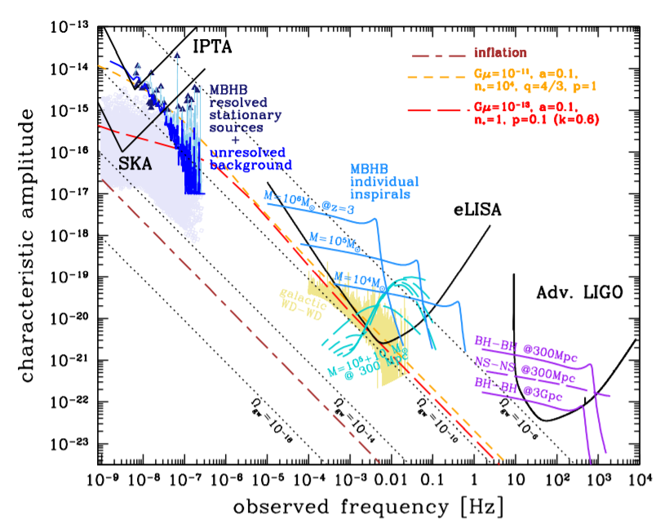

Figure 2: GW amplitude versus frequency ranges explored by the different experiments Adv. LIGO, LISA, and PTAs being used to detect them.

### 2.6 Gravitational wave background (GWB)

Since the formation of the universe there have been many events that could have produced gravitational waves over a long time that has resulted in a stochastic GW background from various weak, independent, and unconfirmed sources. Think of an orchestra of mergers events all adding their own unique signatures and overtones to the gravitational background noise of the universe. A glorious choir of cosmic collisions detectable via precision science experiments.

The big picture from all of this is if detected is the mapping a mapping of the gravitational wave background of the universe that is louder than any single source. It is most likely that as sensitivity of the detectors improve the GWB will be detected first before the individual sources are tuned to with more precision. Similar to the CMB image produced by the COBE and subsequently WMAP satellite that gave us an ‘image’ of the baby picture of the Universe, the detection of the GWB would provide us with an ‘audiogram’ of that baby picture that may even predate the CMB image.

Table 3 shows a comparison of the two phenomena. The image depicting the GWB is only a stylistic rendition of it. Such an image is not yet available but may be within detected as time progresses and with the activation of more sensitive detectors.

|  |  |  |
| --- | --- | --- |
|  | Cosmic Microwave Background | Gravitational Wave Background |
| Depiction |  |  |
| Sources | relic electromagnetic radiation energy from the Big Bang | stochastic gravitational waves produced by collisions of compact masses. |
| Age of the universe | 400,000 ABB (After Big Bang) | < 400,000 ABB (Inflation) |

Table 3: Comparison of CMB and GWB

### 2.7 Gravitational wave astronomical significance: multi messenger astronomy

#### 2.7.1 Tracing the Kilonova, follow up from LIGO Observation

On the 17th of August 2017 at UTC 12:41:04 Advanced LIGO detected a designated as GW170817. 1.7 seconds later at UTC 2017 August 17 12:41:06 a 2 second gamma ray signal registered as GRB 170817A was registered by the FERMI and INTEGRAL space telescopes. The telescopes outlined a region where the two signal sources overlapped and a search for an optical counterpart started immediately. The follow up search was carried out by many telescopes across the EM spectrum, localizing the source of the signal to an object located in RA: 13h 09m and Dec: -23o in the constellation Hydra in the elliptical galaxy NGC 4993 130 Mly away.

The follow up searches pinpointed the signal to a neutron star merger, now classified as a category of phenomena called Kilonova that are short-lived (transient) astronomical event that happen when the compact binaries finally merge. These kilonvas are 1000x the brightness of a typical nova and 1/10th the brightness of a core collapse supernova.

Spectra of the event revealed the traces of heavy elements such as platinum and gold, which allowed further refinements to current models of the origins and abundance of heavy elements in the universe making humanity one step closer to answering the age-old question of: “Where does all this stuff come from?”

The event marked a significant breakthrough in the emerging disciple of multi-messenger astronomy that will become a very important concept in the practice of astronomy in the decades to come.

#### 2.7.2 Multi Messenger Astronomy

With the detections of gravitational waves and neutrinos a new age of astronomy has begun called multi-messenger astronomy where astronomical observations are made by combining observations of different types of information carriers called messengers (I. Bartos & M. Kowalski, 2017) propagating across the universe to get a more coherent picture of a wide range of astrophysical phenomena.

Cross correlation of multi messenger data provides several benefits such as providing insight to phenomena that are opaque/ unobservable in certain messengers but more transparent in others as well providing early warning detection system for events that will allow follow up observations in other messenger to acquire more data such as in the case of GWB 170817. Table 4 details a List of Messengers and their description.

|  |  |  |  |
| --- | --- | --- | --- |
| Messenger | Source | Astrophysical phenomena | Telescope |
| Electromagnetic Radiation | Propagating photons | Stars, Galaxies and AGNs | ALMA, SKA, VLT, Hubble, Chandra X ray Observatory |
| Cosmic Rays | High Energy Particles | Relativistic jets | Pierre Augur Observatory |
| Neutrinos | Tiny Neutral Elementary Particle | Supernovas | ICECUBE |
| Gravitational Waves | Propagating Distortions of Space Time | Non-symmetrical acceleration of compact masses objects | Adv. LIGO VIRGO |

Table 4: List of astrophysical messengers, their sources, and projects to detect them

#### 2.7.3 Future implications of multi-messenger astronomy

Astronomy is only going to get tougher to do on and therefore it will not pay to do it solo. Collaborations will become ever more prevalent as they are already prevalent now. Gone are the days of a lone astronomer sitting on top of Mount Wilson and discovering the rate of expansion of the universe through many nights of observation. The astronomer of today works across multiple borders and as well via online channels to interact with data and observational infrastructure. There will also be a marriage between the astrophysics and the particle physics community. These two communities usually have different modus operandi. Observational astronomers usually operate as lone wolves with data compiled around a certain telescope while particle physicists usually work in large hierarchical organizations such as CERN and Fermilab.

We will need better crossmatching algorithms to match sky surveys of different messengers as larger catalogues developed. Survey cross matching is already an O(n2) level of complexity problem that scales exponentially for larger and larger catalogues. Backend solution jobs and data managing and big data management and archiving in astronomical data will increase demands in IT DBMS solutions.

The skill of making indirect observations will become a key way to understand astrophysical phenomena being studied. By analysing the arrival of one messenger from the same source we can imply and verify it with the state of another and vice versa. This concept can be applied with time domain studies will allow for better understanding of supernova core collapse and relativistic jets and phenomena that produce GWs.

Astronomers across the entire spectrum will have role to play, including radio astronomers.

# 3. Pulsar Astronomy

## 3.1 A Brief History of Pulsars

Pulsars were serendipitously discovered in 1967 by British radio astronomers Anthony Hewish and Jocelyn Bell. While looking for quasars, they discovered a radio source that repeated every 1.33 seconds originating from the same location in the sky following sidereal time. The source was named LGM-1, implying extra-terrestrial beings as a possible origin. However, the detection of a similar repeating sources in a separate part of the sky ruled out the prior hypothesis, in favour of a naturally occurring astrophysical signal. The class of object was designated as CP (Cambridge Pulsar) but current Pulsar naming convention makes it as PSR B1919+21

Pulsars are rapidly rotating neutron stars that emit beams of electromagnetic radiation as a result from particles being funnelled along their magnetic pole axis by very strong magnetic fields billions of times stronger that those of the Earth. This radiation can be attributed to the formation of electron-positron pairs in its magnetosphere (Ruderman & Sutherland, 1975) (Arons & Scharlemann, 1979). Although they emit radiation across a wide range of the electromagnetic spectrum, they are prominently observed in the radio frequencies (80 – 420 MHz).

Pulsars are a product of the end of stellar life cycles when a massive star 10 ~ 30 M ☉ undergoes gravitational core collapse into an object 10 ~ 20 km in diameter. The product of the collapse is an extremely dense object made of degenerate matter kept from further collapse by neutron degeneracy pressure. The densities within a neutron star can reach 5 x 1017 kg per cubic meter. That is 3 x 1014 times greater than the density of the Sun in an object that is a fraction of the size and is comparable to the density found within the atomic nuclei at 3×1017 kg per cubic meter. They are popularly considered planet sized atomic nuclei.

At their formation pulsars experience an increase in angular acceleration due to having a reduced moment of inertia. These objects have rotational periods ranging from a few milliseconds to a few seconds. The fastest know pulsar is PSR J1748 with period of 1.4 ms in the globular cluster Terzan 5 in the constellation of Sagittarius with PSR 1937 being a close second with a period of 1.55 ms. An interesting question arises; “Will they ever pass the less that 1 mili-second mark?”

The rotational periods of pulsars decrease at a very consistent rate over time. This phenomenon is known as “spin down” and has been attributed to a breaking effect caused by the pulsar magnetic field. The rate of slowing down is called period derivative and this and can be used to measure the characteristic age of the pulsar using the equation (1)

tage = p/2pdot (1)

Where p is the period and pdot is the pulsar period derivative.

Younger pulsars start off with a lower period and a higher period derivative while older pulsars have a higher period and lower period derivative because they slow down as they age. Pulsars can be plotted on a log-log graph based on their period and period derivative relationship. This graph is seen in figure 3 called a p-p dot diagram and can be used to categorize pulsars of different types as well as to get an understanding of their evolution.

As the characteristic age increases, pulsars move to the lower right corner of the diagram where there is a death line that separates their lives as detectable radio-loud objects to less detectable radio quiet humdrum neutron stars.

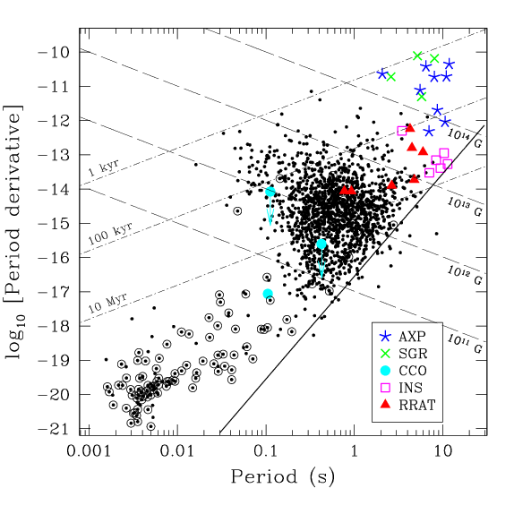

Figure 3: Ppdot diagram of pulsars mapping log period derivative against log period

## 3.2 The uses of pulsars

Pulsars are the universe’s gift to intelligent technological civilizations trying to understand the nature of the ancient and vast Cosmos from which they spring. Their characteristics provide several advantageous uses that further warrant their study.

Because of their accurate rotational periods that can be as accurate to a millionth trillionth of a second (10-18 s) they can be used as a time measure competitive to atomic timescales over long intervals. Pulsars can be used to “time the timescales” of International Atomic Time (TAI/BIPM) (R. Manchester, 2018). Pulsar timing is different from terrestrial timing due to the reasons:

* Independent of terrestrial time scales (day/ week/ month/ year determined by solar system parameters)
* Based on different physical principles (rotation of compact mass over quantum process)
* Continuous for billions of years.
* Measurements of multiple pulsars for more improved accuracy.

The pulsar beams that sweep out cone like pattern can be treated as a lighthouse to provide reference point of navigation for deep space vessels. Pulsars can form a “celestial GPS” system by analysing the TOAs from a set of pulsars with known parameters and solving for the observatory position. For spacecraft navigation, it is most practical to use an on-board X-ray telescope to observe a sample of pulsars emitting X-rays. A positional accuracy of more than 20km is possible with further refinements from Earth based Observation. Chinese satellite XPNAV was launched in 2016 to test x-ray pulsar navigation while NASA has launched the NICER (Neutron Star Interior Composition Explorer) onboard the ISS to also testing this idea.

Since pulsars exhibit characteristics representing extreme physical conditions that would be difficult if not impossible to replicate in a laboratory on Earth, they are often thought of as testbeds for studying certain physical phenomena dialled up to 1000. Some of these conditions may provide insight on the nature of:

* Theories of high energy plasma confinement by intense magnetic fields which may provide insight on how to build more efficient tokamak fusion reactors on Earth.
* Study of very intense magnetic fields billions of times stronger than those of planet Earth.
* Theories of strange configurations of matter which be found inside the cores of neutron stars.
* Theories of extreme gravitational potentials which may provide insight to improve models GR.

As far as the study of GR goes, it was pulsar astronomy that provided the first indirect confirmation of the existence of GW dating back in 1974. It was a discovery worthy of a Nobel prize.

### 3.2.1 Hulse Taylor Binary

Pulsar astronomy brought the first indirect confirmation of the existence of gravitational waves. By studying the rate of orbital decay via pulsar timing of the binary pulsar PSR B1913+16 for over 20 years and invoking a GW model to explain the cumulative shift of the periastron time (Tiburzi, 2018) radio astronomers Joseph Taylor and Russel Hulse were able to match their observation to the theory of energy loss in the system due to some of it being radiated away as gravitational waves. Given enough time pulsar binary will merge in a final collision event discussed in previous section.

As shown in Figure 4. The measured data point dots fit perfectly with the curve that represents the prediction of general relativity. This discovery represents well executed scientific practice and expert model fitting on behalf of the authors as the observations closely met expectation.

### 

Figure 4: The parabola shape represents the decrease in orbital period of pulsar PSR B 1913+16

### 3.2.2 Milisecond Pulsars

On the lower left corner of the p-pdot diagram are a special type of pulsar with rotational periods of < 20 ms. These are a class of pulsars are known as millisecond pulsars (MSPs). These are recycled pulsars that are members of binary systems where a pulsar that was previously dead was brought back to life by accreting mass from its companion star.

A pulsar in this binary system would normally cross the death line after a few tens of millions of years. After which its companion then reaches the red giant phase of stellar evolution during which it begins to transfer mass onto the dead pulsar. The dead pulsar receives a boost in angular momentum, spinning its rotational period up to a few millisecond periods. However, some of the accreting mass buries the magnetic field, reducing it’s the magnetic field strength and the braking effect of the magnetic field on the spin down rate. Millisecond pulsars have a much lower period derivative.

The product of these neutron star binary systems will vary based on the mass of the companion star. A comparison is seen in table 5.

|  |  |  |
| --- | --- | --- |
| Companion | High mass star | Low mass star |
| Product | MSP and neutron star binary if system survives companion supernova. | MSP and white dwarf |
| Evolution/ accretion time | Fast | Slow |

Table 5: Evolution of pulsar binary systems based on companion.

Out of 2700 known pulsars, 217 have a period P < 20 ms and are characterised as MSP. More are continuously being discovered. MSPs are useful for a certain type of experiment to detect low frequency gravitational waves that will be a subject of discussion for the rest of this paper.

## 3.3 Pulsar Timing Arrays (PTA)

A pulsar timing array (PTA) is an experimental set up originally proposed by R. S. Foster and D. C. Backer in 1990 to detect gravitational waves. The objective of the experiment is to look for timing correlations of multiple millisecond pulsars as a function of their angular separation from one another (R. Foster & D. Backer, 1990).

In practice PTA experiments involve comparing the residual differences between the modelled and measured value of the time of arrival (TOA) of the pulses from a pulsar.

The pulsar model parameters (known as ephemeris) are some of the most precise astrometric measurements in astronomy and they are continuously being refined. Some ephemerides that are fit for in PTA experiments are seen in table and can be grouped as different class of parameters

|  |  |  |
| --- | --- | --- |
| Intrinsic pulsar characteristic | Extrinsic characteristics | Properties of intervening medium |
| * Period * Period derivative * Proper motion * Position * Parallax | * Binary parameters * Relativistic binary parameters | * Dispersion measure * Variations of dispersion measure |

Table 6: Example of pulsar timing ephemerids and categories

By comparing the measured and modelled values of these pulsar ephemerides a stream of timing residuals is produced that have within them the influence of gravitational waves and noise processes that may affect the measurement. The influence of the noise processes cannot be avoided. A passing gravitational wave will cause more anti-correlations between pairs of pulsars while the noise processes will not be correlated. This characteristic allows the PTA to be used as a galactic scale gravitational wave detector. Figure 5 shows a graphical representation of how a PTA might work for a pair of pulsars.

Pulsar timing array experiment is currently gaining maturity and is expected to yield promising detection of low frequency gravitational waves in the coming decades.

PTA experiments are only valid given 3 conditions for accurate arrival time measurement

* The pulsar is a stable rotator:

MSPs have low period derivative and satisfies this requirement and are predicted to spin indefinitely. Pulsars with glitches such as RRATs would be ruled out for this experiment.

* A temporally stable integrated pulse profile is acquired: The integrated pulse profile is the coherent sum of many single observed pulses considered to be statistically stable. However, due to factors such as relative motion between pulsar, ISM, and Earth some delays such as scattering, and jitter are produced and need to be corrected for. This work is crucial for achieving the final ticks of precision needed for successful gravitational wave detection.
* Model parameters are as accurate as possible. These values are continuously being updated and involve values approaching ns precision and smaller.

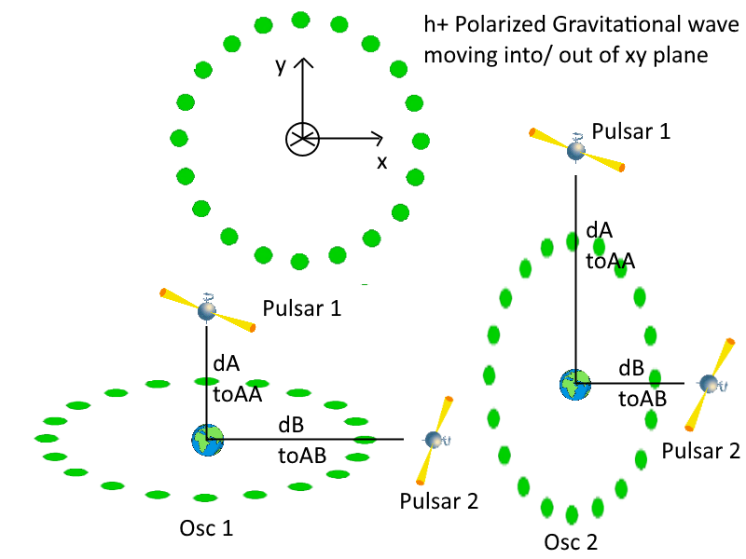

Figure 5: Concept of pulsar timing array visualized with an angle of separation of 90o

The propagation of gravitational waves will change the geometry of space time stretching it one way and squeezing it in the other. In Figure 5 assuming a + polarized gravitational wave with Earth at the centre of the oscillating quadrupole moment and millisecond pulsars 1 and 2 as the end of each distance at distance A and B respectively at Osc1 the distance to Pulsar 1 will decrease causing a low TOA, while the distance to Pulsar 2 will increase causing a higher TOA. At Osc2 the converse is true where the proper distance between Pulsar 2 will decrease producing a low TOA, and the distance to Pulsar 1 will increase causing a higher TOA.

The timing correlations cam be further understood using Hellings and Downs curve

## 3.3.1 Hellings and Downs curve

In 1983 Hellings and Downs calculated the amount of expected correlation between a pair of pulsars as a function of their angular separation for gravitational isotropic radiation of mixed plus (+) and cross (x) polarization. Figure 6 plots this correlation as a function of angular separation. Any pulsar timing experiment must compare their measured correlation with the predicted values of the curve to verify if a signal contains a gravitational wave detection (F. Jenet & J. Romano, 2014). The curve dips at 90o of separation which represents where the expected anti-correlation is expected to peak at -0.1. The analytic equation of the curve is seen in equation 2. Where epsilon is the angle between pulsars.



(2)

The Hellings and Downs curve appears as an enigmatic idea at first that exists specifically to the realm of pulsar timing especially given the way Hellings and Downs derived it from symbolic manipulation on a computer system. However, it is nothing more than a curve describing the correlated response of the geometrical configuration of two receivers.

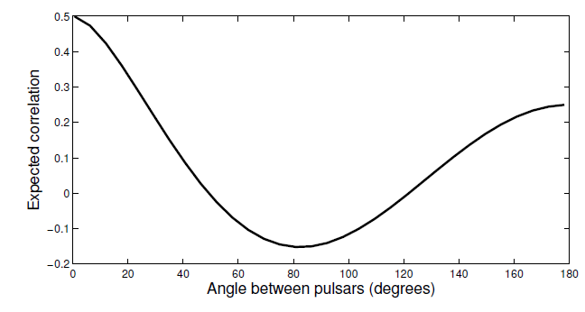

Figure 6: Hellings and Downs curve of correlated response as a function of angular separation. The curve dips the most at 80- 90 degrees which would mean that pulsars with this separation would show the most expected anticorrelation.

## 3.4 Pulsar spectroscopy

The typical setup of a pulsar timing experiment can be seen in Figure 8 (Lorimer and Kramer 2004). The end to end process of the signal analysis begins at the telescope where the signal radiation is collected. It is converted to a baseband signal at the receiver. Afterwards it undergoes de-dispersion and folding to raise the faint signal from the noise floor. Individual pulses are often very weak and need to be averaged over hundreds if not thousands of pulses to resolve a single pulse profile. The integrated pulse profile is then marked with a timestamp from a reference at the observatory clock and sent to a database software such as PSRCHIVE.

The next section looks at the characteristics of pulse profiles and what determines their shape.

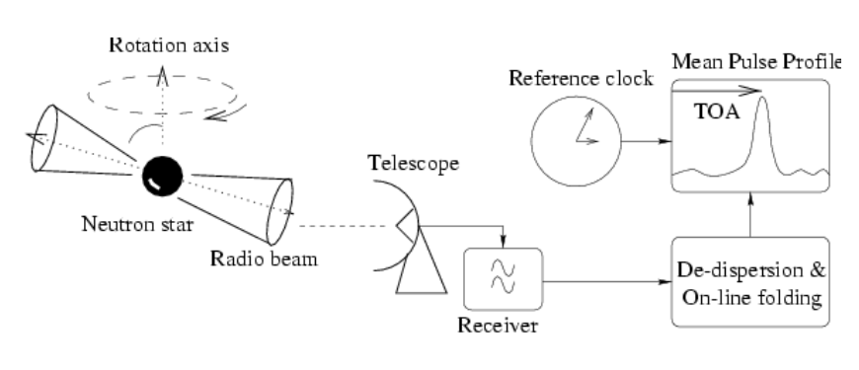

Figure 7: Pulsar timing setup

Different pulsars with different characteristics produce different pulse profiles as seen in figure 9. Pulsar signals are very rich in information content and much can be deduced from the shapes of the integrated pulse profile. Some features that are evident from the pulse profiles are:

* Microstructure.  
  Observed in high time resolution below 200 us to 3 us that appear to repeat every now and gain across a range of frequencies. These structures appear to be quasi periodic
* Giant Pulses   
  Intense pulses that are greater than the mean flux of the pulsar. Found to come from energetic pulsars with strong magnetic fields for some distances.
* Pulse nulling  
  The pulsar suddenly switches off for many pulse periods. The pulsar is starting to show its age, but the main reason for pulse nulling is yet unknown and can be due to a multitude of reasons. MSPs seem to more immune to this phenomenon which backs up their usefulness in PTA experiments.
* Drifting sub pulses.

The pulse profile appears to drift across the duration of the main pulse window at a fixed rate. This is attributed to a rotating carousel of sub beams within a hollow emission cone. Basically, smaller pulses within a larger cone of pulses.

* Mode changing

The pulsar switches between normal and abnormal mode of radiation with observed drastic changes in intensity compared to normal profile.

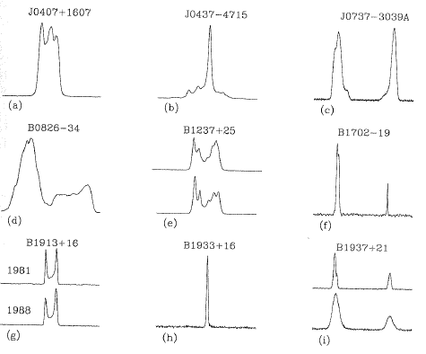

Figure 9: Examples of integrated pulse profiles from different pulsars

Much work throughout the last 50 years of pulsar astronomy has been done to study the nature of these pulse profiles. The astrophysical nature of pulsars as well as other objects (pulsar planets) and phenomena (ISM scintillation) have been understood by their study. One area that is now given focus is how the radiation undergoes changes as it travels through the Interstellar Medium (ISM) that is the collection of hot gas and free electrons that fill the space between the star.

The properties of the pulsar signal are changed as it travels through the ionized ISM such that the appearance of the signal at the receiver does not accurately resemble the same signal that left the pulsar. Three distinct propagation effects are noted.

* Pulse dispersion  
  High Frequency components of the signal arrive at the receiver sooner than the low frequency counterparts. This is because of the frequency dependence of the group velocity of the microwave radiation as it travels through the ISM. The delay time is inversely proportional to frequency i.e. Tdelay ∝ 1/fobs. The constant in this relation is known as Dispersion Measure (DM) that represents the column density of free electrons between the observer and pulsar.   
    
  The equation for DM is seen in equation 3.

DM = ∫ ne dl (3)

DM can be used as a rough (very rough) estimate of the distance to the pulsar when considering a constant column electron density (ne) because more dispersed signals tend to come from farther away.

DM is a vital measure that needs to be accounted for in the measurement of pulse TOA in pulsar timing

* Interstellar scintillation

“Twinkle twinkle quasi-star how I wonder what you are. Greatest mystery from afar” said Russian American astrophysicist George Gamow. For the same reason that DM can only ever be considered a crude estimate of distance to the pulsar, the interstellar medium is not of a constant column electron density. It is highly turbulent and inhomogeneous. It is thicker in some parts thinner in others and this changes over time like a churning foam of sea spray in the cosmic ocean. This inhomogeneity causes phase variations of the pulsar radiation that causes the received pulsar signal to vary on a range of frequencies over time.

Like how stars twinkle in the optical because of the atmosphere, pulsars and quasars scintillate in the microwave because of the interstellar medium. Interstellar scintillation studies can provide insight into understanding the ISM that caused them:

The scale invariant structure of the ISM can be understood by observing pulsar scintillation. By regarding how pulsars scintillate, the sizes of ionized gas clumps from ISM inhomogeneity that pass between Earth and pulsar can be deduced. Scintillation caused by larger clumps are known as ESE or “Extreme Scattering Events” that appear to be quite common in the galaxy. The frequency of these events is an astrophysical mystery and is a frontier of research and inquiry.

When modelled as a thin screen of irregularities as seen in figure 11 the fluctuations of intensity can be correlated over a scintillation bandwidth given by the power law Δf = (f4).

* Pulse Scattering

This phenomenon can be seen in the formation of one-sided exponential tails in the pulse profiles of more distant pulsars. The pulse appears more broadened than it actually is. This effect is more prominent at frequencies lower than 1 GHz and is thus correlated strongly with DM. The apparent pulse broadening can be represented by the convolution of the pulse profile with an exponential time constant (1/e) known as scattering time (τs).

Since this effect elongates the true shape of the pulse profile and decreases the pulse SNR it is very unwanted, and methods are further investigated to mitigate it for the application of more pulse resolution in the quest for better pulsar timing accuracy in PTA experiments or to quote Dr. Willem “beating down the sensitivity curve”. Such techniques are discussed as follows.

### 3.4.1 Multipath Scattering Delay

Multipath scattering delay is the arrival of a copy of the same signal at the receiver at different times via different paths. Multipath scattering is a phenomenon that happens all the time in wireless telecommunications signal propagation. On planet Earth it happens when a radio signals bounce off buildings and cause distortions at the receiver. Comparison of Earth and ISM scenario can be seen in figure 9 and 10.

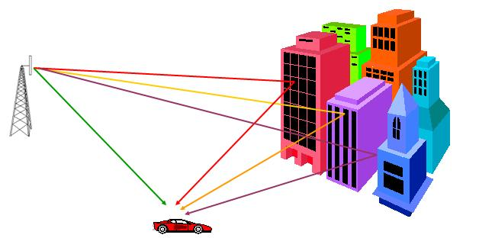

Figure 10: Multipath scattering in wireless communications on Earth. This phenomenon gets worse with multi story parking lots.

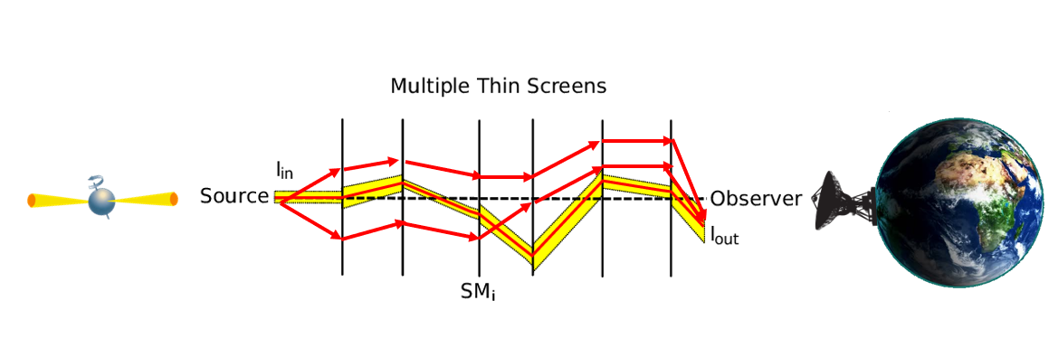

Figure 11: Same concept, different scale. Multipath scattering from ISM due to multiple thin screens with different variations in thickness of the ISM causing different amounts of scattering

From figure 11 the thin screen model is also applicable in discovering the relationship behind scattering time τs since τs ∝ 1/ Δf ∝ f-4. The scaling index can be as low as -2.8 which will increase the adverse effects of scattering time thus broadening the tail.

### 3.4.2 Time/ frequency domain resolution

In light of the propagation effects mentioned mentioned, pulsar spectroscopy relies on different types of signal processing techniques greatly detailed in (Lorimer & Kramer 2004) to compensate for effects of dispersion. For example; via incoherent dedispersion the signal is separated into multiple independent frequency bands using a spectrometer that performs FFT operations and then integrated during a very short on pulse time and to produce an estimate of the dynamic power spectrum. Autocorrelation spectrometers can also be used.

This method results in limitations in finest achievable frequency resolution because the smaller the FFT bandwidth the higher the resultant dispersive smearing. Much care must be taken in selecting the FFT bandwidths to make sure the dispersive smearing does not encompass a significant duration of the on-pulse period. A broader channel bandwidth is allowed for higher frequency.

This was remediated by coherent de-dispersion (Hankins & Rickett, 1975) techniques that removes the effect of dispersion for a known dispersion measure. However, coherent dedispersion is still bound by time and frequency resolution of ΔtΔf > 1.

More can be discussed about this practice (because much has been written about it) but to move on to a subject matter of more novel applications, attention is turned to a promising new technique called cyclic spectroscopy to provide better resolution of the pulse profile.

## 3.5 Cyclic Spectroscopy (CS)

Presented with those challenges of propagation effects of the interstellar medium a relatively new and promising approach to overcome the limitations called cyclic spectroscopy been discovered and implemented (P. Demorest, 2011)

Cyclic spectroscopy methods model the pulsar not as a stationary source but a cyclostationary process. That is a signal process with statistical properties that vary periodically over time. Their correlations exhibit periodicity. Some example cyclostationary process are:

* The daily temperature of a fixed location over many years is considered periodic across the years
* Rush hour traffic at an intersection. Traffic density patterns repeats daily within a given work week.
* Pulsar flux density over pulsar rotations. The pulse profile of a pulsar has statistics relative to phase that tend to repeat for multiple turns of the pulsar.

Cyclostationary modelling of the pulsar signal can decrease the influence of multipath scattering at low frequencies thus providing access to signal content that is unreachable via standard filterbank methods among other benefits

Beginning with an expression for periodic correlation (pc) that is periodic in t but not necessarily periodic in τ seen in equation 4:



(4)

FFT is performed on τ to get the intermediate quantity periodic spectrum (ps) in equation 5:

(5)

A 2nd FFT is done on t to get the cyclic spectrum (cs) seen in equation 6:

 6

Where v is the radio frequency and a is the harmonics of spin frequency.

## 3.5.1 Advantages of Cyclic Spectroscopy

The advantages of cyclic spectroscopy are as follows

* Preserves phase information of the radio signal as seen in equation 6:

  
(6)

* The impulse response of the ISM can be determined via deconvolution. Given standard equation 7 and 8 where x(t) is the pulsar signal and h(t) is the filter response of the interstellar medium.

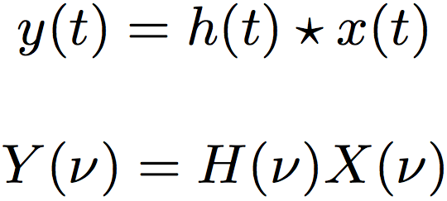(7)

(8)



By inverse Fourier transforming the equation in the red box following the reverse process of the previous steps. First IFFT with a then IFFT with v the time domain impulse response of the ISM can be acquired. This technique is known as interstellar holography which is a projection of the lumpiness of the interstellar medium in terms the multiple scattered wave paths that travel through it from the pulsar to Earth.

Such a holographic picture of signals will provide a better understanding of what causes radio wave scattering in the ISM and will allow for fine tuning of instrumentation for pulsar timing arrays that search for low frequency gravitational waves via pulsar timing arrays mentioned in previous sections.

# 4. Conclusion and Future Works

In the 50 years since their discovery pulsars continue to be a source of astrophysical mystery and one that may connect us with some very fundamental truths about the universe that may not be so evident here on Earth. We must study pulsars to find them.

There is much immediate and long-term benefit for studying pulsars and their applications. Especially for the needs of any emerging technical civilization (human or otherwise). If our civilization is to venture to the stars it would be of great interest to understand what happens to the large ones when they die.

## 4.1 Birefringent Scintillation

Follow up work should be done to further investigate the multipath propagation delays and methods to further decouple the delay from the ISM using CS. One interesting phenomenon is the occurrence of birefringent scintillation (multiple indices of refraction) such as that found in calcite and plastics. This also happens in the ISM and effects the multipath propagation delay.

This challenge represents a low hanging fruit in pulsar astronomy that can be picked with a practice CS application project in COMP 811.

## 4.2 Final Remarks

TBC in continued in COMP 811.

# References

[1] Tiburzi, C. (2018). Pulsars Probe the Low-Frequency Gravitational Sky: Pulsar Timing Arrays Basics and Recent Results. Publications of the Astronomical Society of Australia, [online] 35, pp.1-16. Available at: https://arxiv.org/pdf/1802.05076v1.pdf [Accessed 20 Jun. 2019].

[2] Mingarelli, C. (2019). Probing supermassive black hole binaries with pulsar timing. Nature Astronomy, [online] 3(1), pp.8-10. Available at: https://arxiv.org/abs/1901.06785 [Accessed 20 Jun. 2019].

[3] Milosavljević, M. (2003). The Final Parsec Problem. AIP Conference Proceedings, [online] pp.1-4. Available at: https://arxiv.org/abs/astro-ph/0212270 [Accessed 20 Jun. 2019]

[4] Bhattacharya, M., Kumar, P. and Smoot, G. (2019). Mergers of black hole–neutron star binaries and rates of associated electromagnetic counterparts. Monthly Notices of the Royal Astronomical Society, [online] 486(4), pp.1-4. Available at: https://arxiv.org/abs/1809.00006 [Accessed 20 Jun. 2019].

[5] Bartos, I. and Kowalski, M. (2017). Multimessenger Astronomy. [online] Available at: https://iopscience.iop.org/book/978-0-7503-1369-8 [Accessed 20 Jun. 2019].

[6] Ruderman, M. and Sutherland, P. (1975). Theory of pulsars - Polar caps, sparks, and coherent microwave radiation. The Astrophysical Journal, [online] 196, p.51. Available at: http://adsabs.harvard.edu/abs/1975ApJ...196...51R [Accessed 20 Jun. 2019].

[7] Arons, J. and Scharlemann, E. (1979). Pair formation above pulsar polar caps - Structure of the low altitude acceleration zone. The Astrophysical Journal, [online] 231, pp.1-5. Available at: http://adsabs.harvard.edu/abs/1979ApJ...231..854A [Accessed 20 Jun. 2019].

[8] Manchester, R. (2017). Pulsar timing and its applications. Journal of Physics: Conference Series, [online] 932, pp.1-10. Available at: https://iopscience.iop.org/article/10.1088/1742-6596/932/1/012002 [Accessed 20 Jun. 2019]. [9] Foster and Backer 1990

[10] Jenet, F. and Romano, J. (2015). Understanding the gravitational-wave Hellings and Downs curve for pulsar timing arrays in terms of sound and electromagnetic waves. American Journal of Physics, [online] 83(7), pp.1-6. Available at: https://arxiv.org/abs/1412.1142 [Accessed 20 Jun. 2019].

[11] Lorimer, D. and Kramer, M. (2012). Handbook of pulsar astronomy. Cambridge: University Press.

[12] HANKINS, T. and RICKETT, B. (1975). Pulsar Signal Processing. Methods in Computational Physics: Advances in Research and Applications, [online] pp.55-129. Available at: https://www.sciencedirect.com/science/article/pii/B9780124608146500073 [Accessed 20 Jun. 2019].

[13] Demorest, P. (2011). Cyclic spectral analysis of radio pulsars. Monthly Notices of the Royal Astronomical Society, [online] 416(4), pp.2821-2826. Available at: https://arxiv.org/abs/1106.3345 [Accessed 20 Jun. 2019].

[14] Margalit, B. and Metzger, B. (2017). Constraining the Maximum Mass of Neutron Stars from Multi-messenger Observations of GW170817. The Astrophysical Journal, [online] 850(2), p.L19. Available at: https://arxiv.org/abs/1710.05938 [Accessed 20 Jun. 2019].